**USER MANUAL**

**for**

**REMIND ME !!**

**A SMART WAY TO LIVE IS TO REMEMBER REMIND ME !!**

**By**

**MPG4**

PRASHANTH VENNA

MALLIKA PALREDDY

MEHABOOB GORI

VENKATA PURNESH

**TABLE OF CONTENTS:**

1. Introduction
2. Hardware Requirements
3. Software and tools required
4. Services offered by the app
5. Directions to use
6. List of Error detections and handling.
7. Sample usage of app with explanation.
8. Security entities.
9. Efficiency of this app from bugs and deficiencies.
10. **Introduction:**

Remind Me!! Is a multi-featured android app with shopping, navigation, voice alert systems. This unique application unlike conventional applications that provide regular text alerts or applications used for shopping.

This application can simultaneously used for shopping and can also be used for journey alerts using navigation. Most interesting thing is using a user interactive voice reminder that makes this application more attractive. The unique user GUI for this app gives it finished look and attractive.

1. **HARDWARE REQUIREMENTS:**

This application has a very basic hardware requirements like other android applications.

It takes 8Mb of phone memory for installation, however the basic requirement for smooth functioning of this application are 128Mb of internal phone memory, with 256Mb Ram that has basic graphic features.

The phone should be equipped with GPRS technology.

It should also contain Location sensor and accelerating sensor for detecting the location and motion of the user.

1. **Software requirements:**

This is an android based application and is tested for using on all android versions from 4.3.1 jelly Bean to android Lollipop.

1. **SERVICES OFFERED BY THE APP:**
2. Creating an account in remind me app
3. Searching for a desired store
4. Preparing a list of items
5. Adding voice reminders to the lists prepared
6. Adding journey details
7. Updating the journey details
8. Adding the halts in the journey
9. Voice reminder for journey departure and arrival
10. Voice reminder for halts in the journey
11. Navigation from source to destination through halts.
12. **DIRECTIONS TO USE:**
13. For a new user signup by providing the signup details
14. It is mandatory to give each and every detail during the signup.
15. This app is designed for reset of forgot password by providing the verification details for the security question.

It is necessary that the details provided in the signup should be matched with the details provided during the reset of password if the user forget their password.

1. Login with the username and password (provided during signup process) after signup.
2. Depending on the service that is required from the above services that are provided navigate to corresponding tabs.

***FOR SHOPPING***:

1. For shopping an item navigate to shopping tab.

Here user has 3 services. User (you)

1. Can add an item for the list of shopping by providing the details of the item.
2. Can search an item on the store and can set the voice reminder for the prepared list of items in the shopping by giving the time and date and a user recorded voice reminder by clicking on the **“record your reminder”** icon.
3. Can search desired store by providing the address of the store.
4. Can add the item desired directly by clicking on the navigated store on the map.

***FOR JOURNEY***

1. For journey reminders user(you) can create a journey record by clicking on add journey.
2. Give the source and destination details and the arrival time of the journey, date and time of journey.
3. Click on “Record your reminder” for recording the voice reminder for journey.
4. On clicking the journey user(you) have 3 options for show, update delete of journey details respectively.
5. On clicking the update the user(you) can update his journey details.
6. User (you) can add a new halt to the journey by clicking on add halt tab.
7. At anytime the user can click on the start tab for the reminder to get activated for the navigation.
8. The user has an option to see the navigation of his journey from source to destination all along through halts by clicking on the pop button for maps present on the top of journey list.
9. Finally in the about tab there is a brief description about the app and contact list if required.
10. **List of Error detections and handling.**
11. Signup errors and login errors:

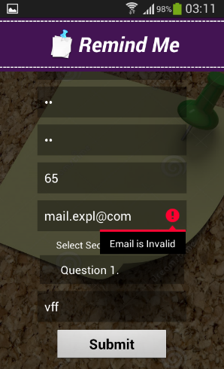 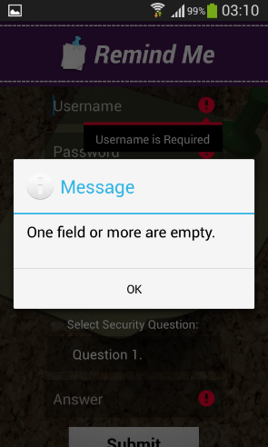 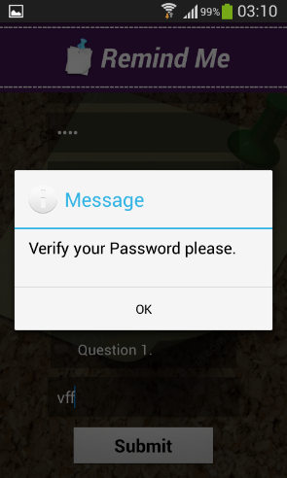 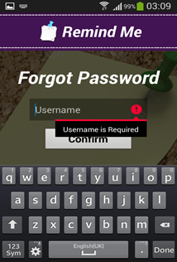

During the signup process every field should be provided else a one field empty error appears.

If the password provided doesn’t matches when it is re-provided during signup a verify password error appears.

1. **Errors during accessing shopping tab:**

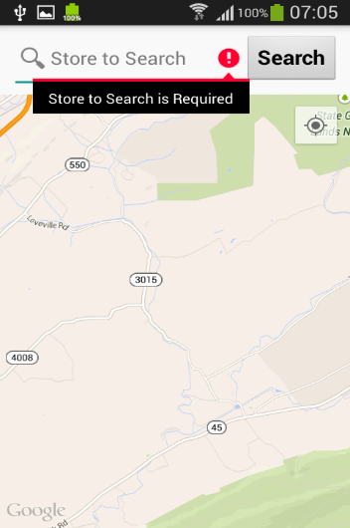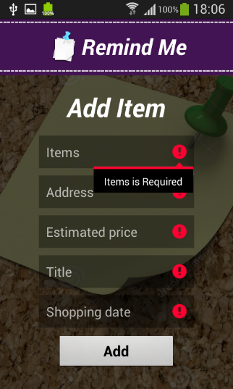 Like that in signup and login pages the add item in shopping tab also need all the fields to be filled else an error message for that field appears requiring that specific field information.

**3.Errors during accessing journey tab :**

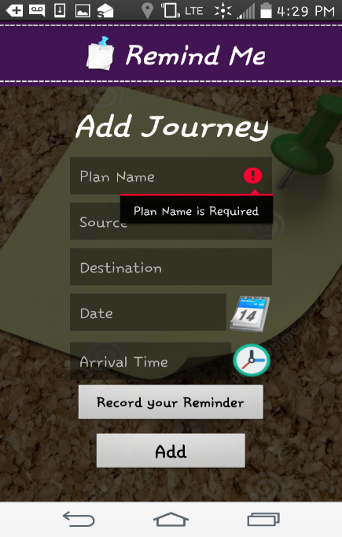

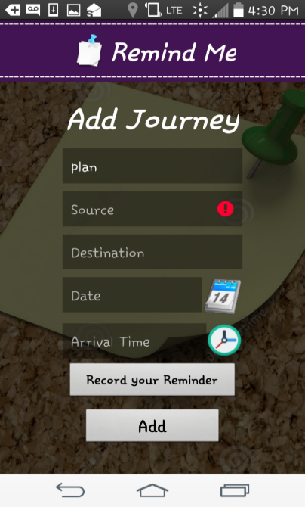 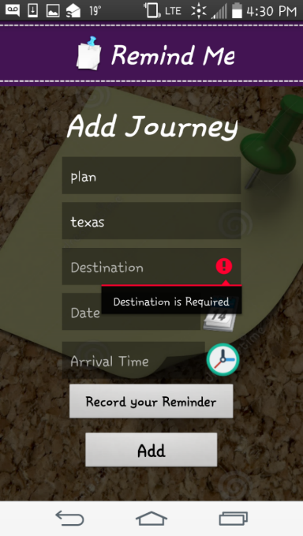

All the fields should be provided during adding of a journey.

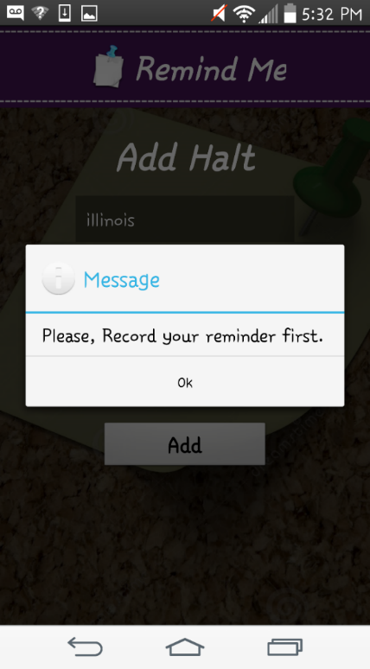

During each final step in the journey tab either for adding a journey voice reminder or halt voice reminder the user need to record their voice message reminder else the following message appears.

NOTE : The user need to be caution while providing their departure and arrival times in journey tab.

1. If the departure time is ahead of the arrival time the journey cannot be added to the reminder list and a popup message appears describing the error for it.
2. **Sample usage of app with explanation**.
3. Signup

Provide the details and signup

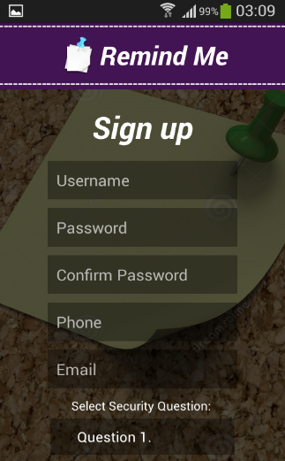

1. Login

Provide the details required and login.

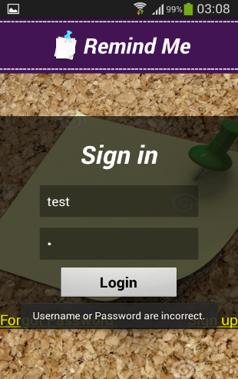

1. Add an item

Providing the details for the field and adding an item to list

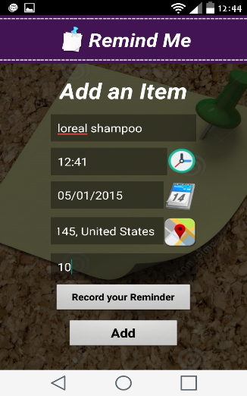

1. Search an item in the store and adding voice reminder.

Searching an item for eg: laptop in the store

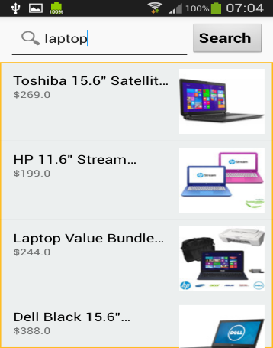

1. Search the store

Searching nearby store

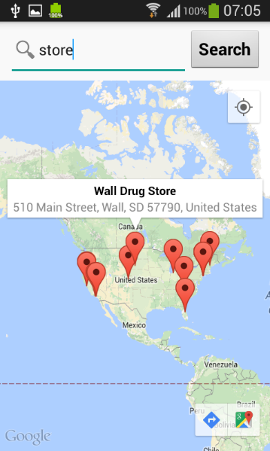

1. Add a journey to the list

Providing the details and adding journey.

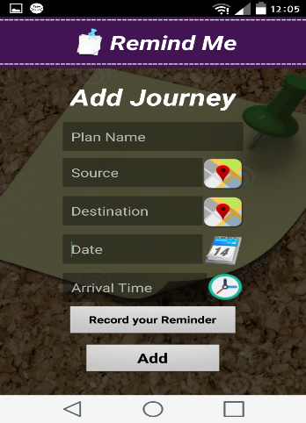

1. Add a halt by updating the journey.

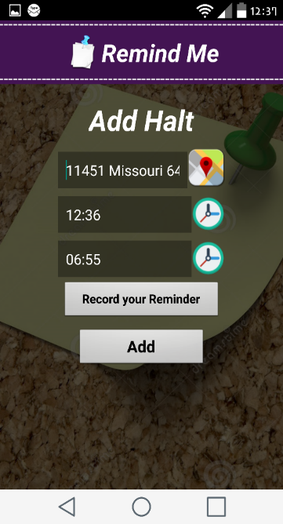

1. Show or update or delete journey

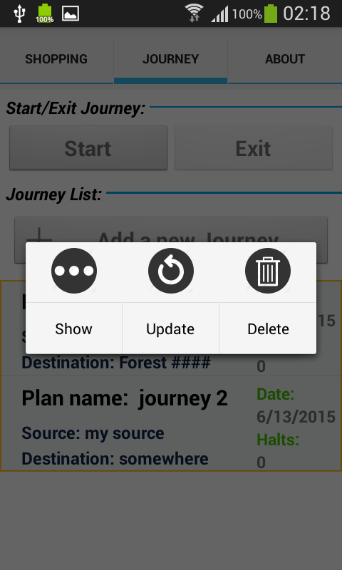 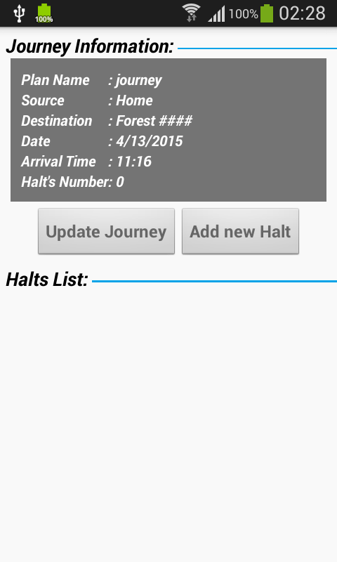 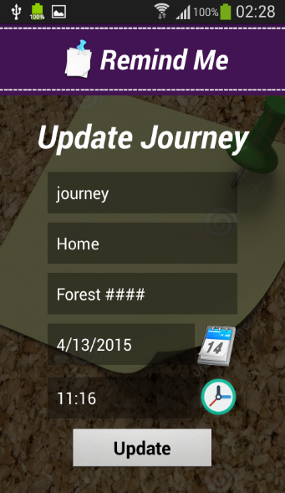

1. Start or stop the reminder

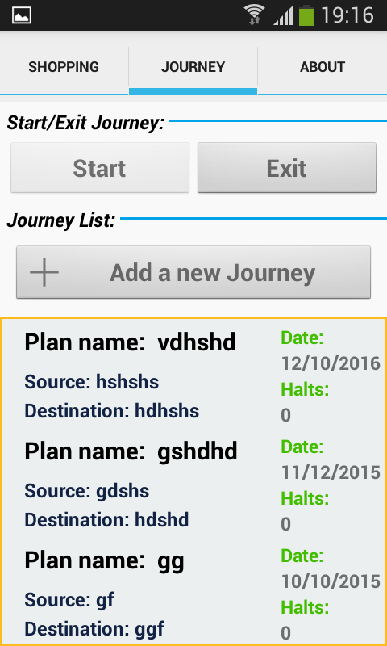 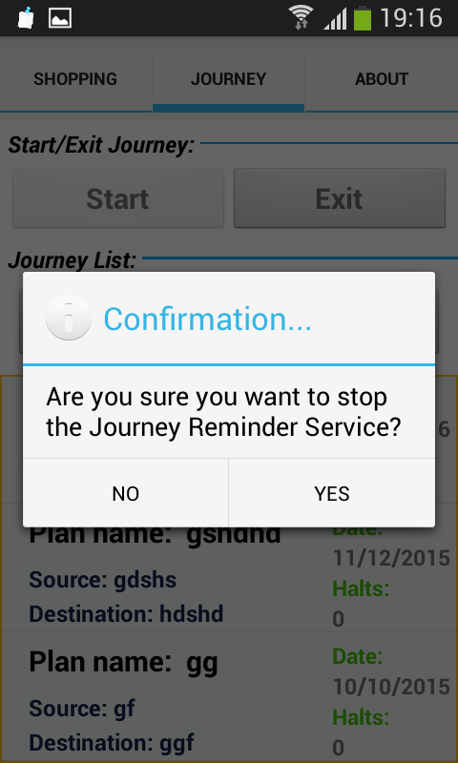

1. About the app

Details about app description and contact info.

1. **Security entities**

A sha-2 encryption is used for storing user data like passwords and this app can be considered more secure app than any other existing reminder and shopping journey apps.

1. **Bugs and deficiencies:**

This app is free from bugs and deficiencies and is tested for all performance issues and passed well for use commercially.